**Assignment1**

Mengxi Nie G48739076 eva_happylife@gwu.edu

**Q1:**

1. /[13579][02468]/
2. /[A-Za-z]\W[0-9]/
3. /\b^[A-Z][a-zA-Z]*[:punct:]\b/
4. /(?!)ping/
5. /\b[0-9]{1,2}\.[0-9]{1,2}\.[0-9]{2}\b/

**Q2:**

The regular expression is

*/^((25[0-5]|2[0-4]\d|((1\d{2})|([1-9]?\d)))\.){3}(25[0-5]|2[0-4]\d|((1\d{2})|([1-9]?\d)))/*

I use Perl and the file is Q2.pl

OS: ubuntu14 64bit

Running Result:

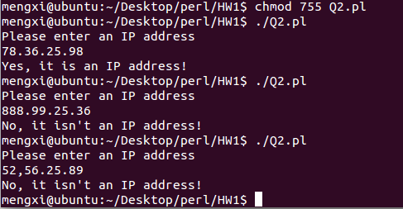

**Q3:**

I use Perl and the file is Q2.pl

OS: ubuntu14 64bit

Running Result:

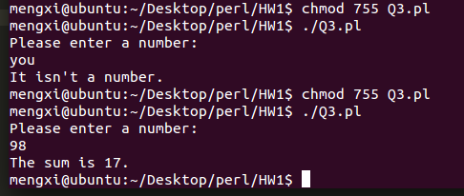

**Q4:**

I use Python2.7 and the file is *hwk1_p4.py*. The original sentences are stored in *hwk1_p4.txt and* the result is stored in the file *hwk1_p4_result.txt.*

OS: Windows10 64bit

**Q5：**

I use Python2.7 and the file is *hwk1_p5.py.*

OS: Windows10 64bit

Running Result:

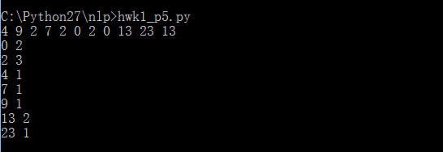

**Q6：**

I use Python2.7 and the file is *hwk1_p5.py.* The result is stored in the file *hwk1_p6_result.txt.*

OS: Windows10 64bit

**Q7：**

*grep -A 1 'lang="EN"' uncorpora_plain_20090831.tmx | grep -i "Human Rights" | wc -l*

Ans: 5663

**Q8:**

1. *wc -l uncorpora_plain_20090831.tmx*

Ans: 1501316

1. *grep -o ‘<seg>’ uncorpora_plain_20090831.tmx | wc -l*

Ans: 434034

1. *grep "<[^(s|\/)].*>" uncorpora_plain_20090831.tmx | wc -l*

Ans: 560895

1. *grep -A 1 ‘lang=”EN”’ uncorpora_plain_20090831.tmx | grep ‘<seg>’ | wc -l*

Ans: 72339

1. *cat uncorpora_plain_20090831.tmx | grep -o 'lang="\w\w"' | sort | uniq -c*

*72339 lang="AR"*

*72340 lang="EN"*

*72339 lang="ES"*

*72339 lang="FR"*

*72339 lang="RU"*

*72339 lang="ZH"*

**Q9:**

1. *grep -A1 'lang="EN"' uncorpora_plain_20090831.tmx | awk -F'>|<' '{print $3 > "uncorpus.eng.txt" }'*
2. *egrep -o* *"[a-zA-Z-]+|([A-Z]\.)+|('[a-z]\b)" uncorpus.eng.txt | wc -w*

*ans : 2583849*

1. *cat uncorpus.eng.txt | egrep -o "[a-zA-Z-]+|([A-Z]\.)+|('[a-z]\b)" | sort | uniq | wc -l*

*ans: 15362*

1. *cat uncorpus.eng.txt | egrep -o "[a-zA-Z-]+|([A-Z]\.)+|('[a-z]\b)" | sort | uniq -i | wc -l*

*ans:12605*

1. *grep -P -o '\b\d+\b' uncorpus.eng.txt | wc -l*

*ans: 133130*

1. *uncorpus.eng.txt | egrep -o "([0-9]{1,3}(\,[0-9]{3})*(\.[0-9]+)?)|([0-9]+)" | wc -l*

*ans: 133029*

1. *egrep -o '\b[A-Z]([a-zA-Z-]*|(\.([A-Z]\.)*))\b' | wc -l*

*ans: 451347*

1. *grep -o -P '[a-zA-Z]+.*' uncorpus.eng.txt | grep -o -P '(?<=^)[a-zA-Z]+' | sort | uniq -c | sort -nr | head -15*

*ans:*

4821 Recalling

3713 Requests

2811 The

2524 Also

2417 Calls

2166 Adopted

2090 Noting

2054 RESOLUTION

2034 Welcomes

1969 Decides

1694 Urges

1679 Recognizing

1669 Reaffirming

1646 Notes

1606 Encourages

1. *grep -o -P '[a-zA-Z]+.*' uncorpus.eng.txt | grep -o -P '(?<!^)\b[A-Z]([a-zA-Z-]*|(\.([A-Z]\.))*)\b' | sort | uniq -c | sort -nr | head -15*

*ans:*

19938 United

19162 Nations

14934 States

9302 December

8961 Secretary-General

8621 Assembly

8503 General

7001 Committee

5731 Convention

5595 International

3902 Declaration

3867 Commission

3726 Conference

3688 Rights

3593 Development

1. *grep -P -o '(?<!\/)\b(M{0,4}(CM|CD|D?C{0,3})(XC|X?L|L?X{1,3})(IX|IV|V?I{0,3})|M{0,4}(CM|CD|D?C{0,3})(XC|XL|L?X{0,3})(IX|I?V|V?I{1,3}))\b' uncorpus.eng.txt | wc -l*

ans: 3611

**Q10:**

egrep -o '\b[a-zA-Z]+\b' uncorpus.eng.txt | sort | uniq -c | sort -nr | head -40

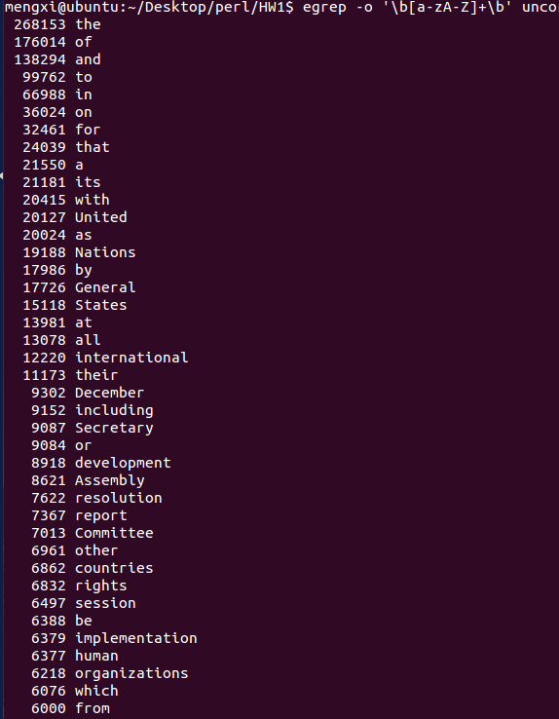

egrep -o '\b[a-zA-Z]+\b' uncorpus.eng.txt | sort | uniq -c | sort -n | head -40

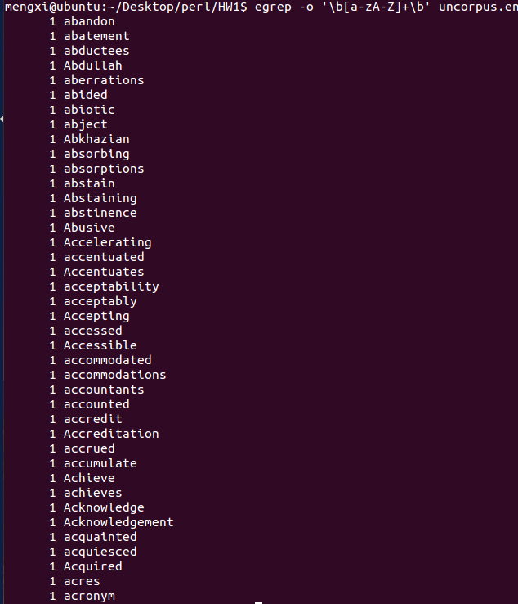

Top words are mostly preposition and words that are associated with the essay theme. Most bottom words come from the same root. I am not surprised by the top words result but shocked with the bottom words result because I thought the bottom words were some vocabularies which expressed the contrary of the same. For example, an essay is about happy then some negative words appear rarely.

**Q11:**

**A:**

1. *grep -A1 'lang="EN"' uncorpora_plain_20090831.tmx | grep -o -P '(?<=<seg>).*(?=</seg>)'| grep -o -P '(?<=\s|\A)[^\s]+(?=\s|\Z)' | sort | uniq -c | sort -nr | head -20*

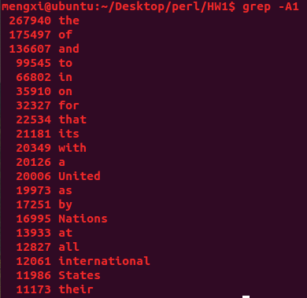

1. *grep -A1 'lang="AR"' uncorpora_plain_20090831.tmx | grep -o -P '(?<=<seg>).*(?=</seg>)'| grep -o -P '(?<=\s|\A)[^\s]+(?=\s|\Z)' | sort | uniq -c | sort -nr | head -20*

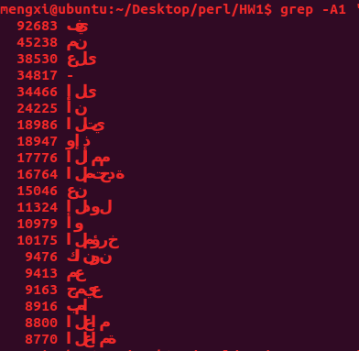

1. *grep -A1 'lang="ES"' uncorpora_plain_20090831.tmx | grep -o -P '(?<=<seg>).*(?=</seg>)'| grep -o -P '(?<=\s|\A)[^\s]+(?=\s|\Z)' | sort | uniq -c | sort -nr | head -20*

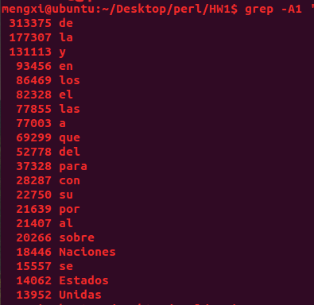

1. *grep -A1 'lang="RU"' uncorpora_plain_20090831.tmx | grep -o -P '(?<=<seg>).*(?=</seg>)'| grep -o -P '(?<=\s|\A)[^\s]+(?=\s|\Z)' | sort | uniq -c | sort -nr | head -20*

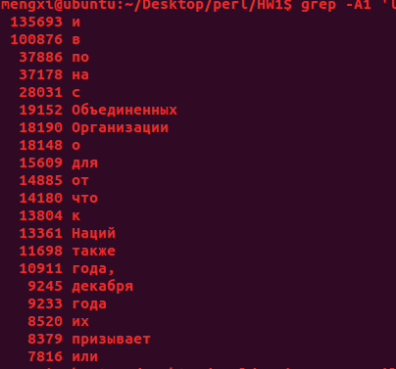

**B:**

1> Arabic

|  |  |
| --- | --- |
| **Word** | **Meaning** |
| 92683 في | At |
| 45238 من | From |
| 38530 على | On |
| 34817 - | - |
| 34466 إلى | To |
| 24225 أن | That |
| 18986 التي | Which |
| 18947 وإذ | Having, taking |
| 17776 الأمم | Nations |
| 16764 المتحدة | United Nations |
| 15046 عن | about |
| 11324 الدول | States |
| 10979 أو | or |
| 10175 المؤرخ | Of |
| 9476 كانون | Canon |
| 9413 مع | With |
| 9163 جميع | All |
| 8916 بما | including |
| 8800 العام | General |
| 8770 العامة | The public |

2> Spanish

|  |  |
| --- | --- |
| **Word** | **Meaning** |
| 313375 de | From, of |
| 177307 la | La |
| 131113 y | And |
| 93456 en | In |
| 86469 los | Los |
| 82328 el | El |
| 77855 las | Las |
| 77003 a | To |
| 69299 que | Which |
| 52778 del | Of the |
| 37328 para | For |
| 28287 con | With |
| 22750 su | Su |
| 21639 por | For |
| 21407 al | Al |
| 20266 sobre | On |
| 18446 Naciones | Nations |
| 15557 se | Himself, herself, itself |
| 14062 Estados | States |
| 13952 Unidas | United |

3> Russian

|  |  |
| --- | --- |
| **Word** | **Meaning** |
| 135693 и | And |
| 100876 в | In |
| 37886 по | By |
| 37178 на | Per |
| 28031 с | Sec |
| 19152 Объединенных | United |
| 18190 Организации | Organizations |
| 18148 о | O |
| 15609 для | For |
| 14885 от | From |
| 14180 что | That |
| 13804 к | To |
| 13361 Наций | Nations |
| 11698 также | Also |
| 10911 года, | Years, |
| 9245 декабря | December |
| 9233 года | Years |
| 8520 их | Of them |
| 8379 призывает | Encourages |
| 7816 или | for |

I think the prepositions and proper noun are similar in various languages. However, because of the methods of translating and language convention, some top words are different in different languages.